LABORATORIO ARTIGIANO RETI
di ARCHETTI CARLO
Reti da Pesca – Sport – Caccia
Recinzione Impianti Sportivi
Antinfortunistica – Acquacoltura
25058 SULZANO (BS) – Via Tassano, n. 8
Tel. e Fax 030/985290 – Tel. Ab. 030/985191
Cell. 328 0562071 c.f. RCHCRL64C01F532U – P.I. 03216410179
www.retiarchetti.it – info@retiarchetti.it
www.retiarchetti.com – info@retiarchetti.com
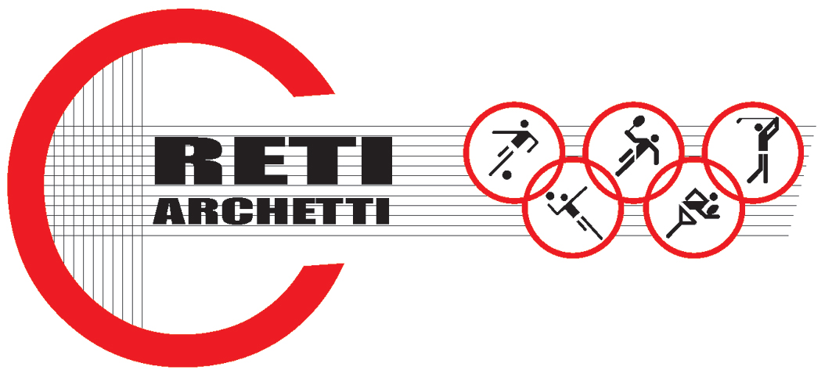

TECHNICAL DATA SHEET ART.CODE: B 1

NYLON NET, KNOTTED, MESH mm 30X 30 AND THICKNESS mm 0,50

- “INVISIBLE” net, made of high resistant single string nylon, water repellent, squared mesh mm 30 x 30, thickness mm 0.50.
Since it is not too much visible, this kind of net is used as protection against birds on churches, monuments and buildings facades.

Technical features

- MATERIAL: single string Nylon
- COLOR: light green, transparent
- YARN THICKNESS: 0,50 mm.
- NET: squared mesh
- MESH: mm. 30 x 30
- WEIGHT: 40 g. /sq m
- EDGE STRIP: with a 6 mm nylon braid
- WATER ABSORBTION 0,01% - WATER REPELLENT–

Each net can be manufactured with length and width on customer request. Nets are complete with a reinforced strip along the edge with a 6 mm braid sewed to the net. A piece of rope at the angles makes the installation easier.

